**LICENSE PLATE RECOGNITION SYSTEM USING MATLAB**

**A Project Report**

***Submitted by***

**Mridul Jajodia (189303187)**

**Shubh Rajput (189303168)**

***In partial fulfilment for the award of the degree***

***of***

**BCHELOR OF TECHNOLOGY**

**IN**

**Information Technology**

**At**



**MANIPAL UNIVERSITY JAIPUR**

**JAIPUR**

**April 2019**

**DECLARATION BY THE CANDIDATE**

I hereby declare that the work, which is going to be presented in the Project, entitled “License Plate Recognition System” to be submitted in partial fulfilment of the requirement for the award of Degree of “Bachelors of Technology” in Department of Computer and Communication with Specialization in Digital Image Processing and to be submitted to the Department of Computer and Communication, Manipal University Jaipur is an authentic record of my own investigations carried out under the supervision of Dr. Vivek K Verma , Assistant Professor, SCIT, Manipal University Jaipur.

I have not submitted the matter presented in this project anywhere for the award of any other degree.

Mridul Jajodia

189303187

Shubh Rajput

189303168

**ACKNOWLEDGEMENT**

The enduring pages of the work are the cumulative sequence of extensive guidance and arduous work. I wish to acknowledge and express my personal gratitude to all those without whom this work could not have been reality.

I feel very delighted to get this rare opportunity to show my profound senses of reverences and indebtedness to my esteemed Dr. Vivek K Verma for his keen and sustained interest, valuable advice, throughout the course of which led my report, to a successful completion. For this kind act of consideration I be holder to him in special manner and no one can fully convey my feelings of respect and regard for them.

#### LIST OF FIGURES

|  |  |  |
| --- | --- | --- |
| **Figure 1.1** | Processing of automatic vehicle plate recognition | **3** |
| **Figure 2.1** | Flow Diagram of ANPR | **4** |
| **Figure 2.2** | Image segmentation | **6** |
| **Figure 2.3 (a)** | car images | **6** |
| **Figure 2.3 (b)** | MATLAB experimental screenshots | **7** |

#### TABLE OF CONTENTS

|  |  |  |  |
| --- | --- | --- | --- |
| **PARTICULARS** | | | **Page** |
| Candidate’s Declaration | | | ii |
| Acknowledgement | | | iii |
| List of Figures | | | Iv |
| **Abstract** | | | **1** |
| **1** | **Introduction** | | **2** |
|  | 1.1 | Background | 2 |
|  | 1.2 | Project Motivation | 2 |
|  | 1.3 | Aims and Objectives | 2 |
|  | 1.4 | Implications | 3 |
| **2** | **Implementation** | | **4** |
|  | 2.1 | Methodology | 4 |
|  | 2.2 | Work flow process | 5 |
|  | 2.3 | Experimental results | 7 |
| **3** | **Conclusion** | | 9 |
|  |  |  |  |
| **References** | | | 9 |

**ABSTRACT**

The Automatic Number plate Recognition system is based on image processing technology. It is one of the necessary systems designed to detect the vehicle number plate. In today’s world with the increasing number of vehicle day by day it’s not possible to manually keep a record of the entire vehicle. With the development of this system it becomes easy to keep a record and use it whenever required. The main objective here is to design an efficient automatic vehicle identification system by using vehicle number plate. The system first would capture the vehicles image as soon as the vehicle reaches the security checking area. The captured images are then extracted by using the segmentation process. Optical character recognition is used to identify the characters. The obtained data is then compared with the data stored in their database. The system is implemented and simulated on MATLAB and performance is tested on real images. This type of system is widely used in Traffic control areas, tolling, parking area. etc. This system is mainly designed for the purpose of security system.

Keywords: Number Plate Recognition, Gray Processing, Image Acquisition, Image Binarization, Template Matching.

**Chapter - 1**

**INTRODUCTION**

* 1. **Background**

With the increasing number of vehicle in today’s world it’s not possible to manually keep a record of the entire vehicle. There need to be a man standing 24*7 to note down the number. It’s a time consuming process and require manpower. Furthermore the data stored manually is not readable after a long time. Many detection methods were developed in various countries which were successfully implemented. But due to development of the technology, many methods took its root in developing more accurate detection.

* 1. **Project Motivation**

As a part of our curriculum in Computer and Communications Department we have been taught Digital Image Processing, so this project has been motivated from there. We wanted to explore more of MATLAB and started gaining interest in it. And as a user of MATLAB while thinking about a topic we came across License plate recognition system as a topic which would be unique and effective in day to day life.

* 1. **Aims and Objectives**

Our aim is to overcome all these limitations here we tried to develop a system which would automatically detect the number plate and store it in its database. Later when the information is required one can get it and use it. This process also helps to get the correct result compared to manually one. License Plate Recognition is an image processing technology which is used to identify the vehicles and details by extracting and recognizing their license plate number. The License Plate number is used to extract more information about the vehicle and its owner and used for further processing.

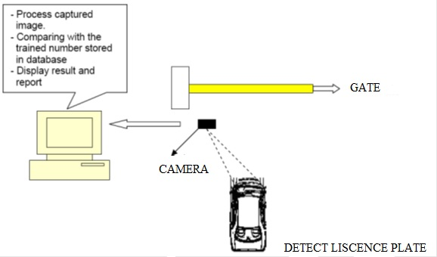

**Figure 1.1**: Processing of automatic vehicle plate recognition

* 1. **Implications**

License plate identification system includes five parts: vehicle images acquisition, license plate pre-processing, license plate character segmentation and positioning, character recognition. This paper studies the pre-treatment of the vehicle images. The image is affected by the interference factors, such as illumination, climate and background, which has an effect on the subsequent license plate Identification. The task is to construct the algorithm and recognizes can be done using MATLAB. MATLAB is very efficient as it have built-in-function tools for neural network and image processing. The advantages of MATLAB can be classified as follows: Platform independence, predefined function and device-independent plotting, Graphical User interface and MATLAB compiler. It integrates computation, Algorithm development , Modeling simulation, and prototyping ,Data acquisition , Data analysis, exploration, and visualization and Application development, including graphical user interface building . MATLAB is high performance programming language which has an easy-to-use environment where problems and solutions are expressed in familiar mathematical notation.

**Chapter - 2**

**IMPLEMENTATION**

**2.1 Methodology**

The first and the most important part in this process is the software model. The software model uses the image processing technology. The programs are implemented in MATLAB. The algorithm is divided into following parts: Capture image, Pre-processing, Plate region extraction, Segmentation of character in the extracted number plate, Character recognition, Comparison with database and Indicate result. The flow chart of license plate recognition system implementation in this work is shown in the following figure. There are various steps in this approach and these are implementation in MATLAB.

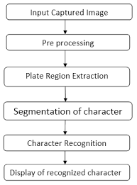

**Figure 2.1:** Flow Diagram of ANPR

more information about the vehicle and it’s owner details which is used for further processing

**2.2 Work Flow Process**

**Capture of Image:**

The first step is the capture of image. The image is captured by electronic device. Digital Camera or Webcam. The image captured is stored in JPEG format. Later on it is converted in to gray scale image in MATLAB.

**Pre-processing:**

The next step after capturing the image is the pre processing of the image. When the image is captured there is lot of disturbances and noises present in the image for which the image can’t be used properly. So in this step the noises from the image are required to be cleared to obtain an accurate result.

a. **Gray Processing**: this step involves the conversion of image in to Gray levels. Color images are converted in to Gray image. According to the R, G, B value in the image, it calculates the value of gray value, and obtains the gray image at the same time.

b. **Median Filtering**: media filtering is the step to remove the noises from the image. Gray level cannot remove the noises. So to make image free from noise media filtering is used.

**Plate region extraction:**

The most important stage is the extraction of number plate from eroded image significantly. The extraction can be done by using image segmentation method. There are numerous image segmentation methods available in various literatures. In most of the methods image binarization is used.

**Character segmentation:**

In this step get the o/p of extracted number plate using labeling components, and then separate each character and split the each and every character in the number plate image by using split and also find the length of the number plate, then find the correlation and database if both the value is same means it will generate the value 0-9 and A - Z, and finally convert the value to string and display it in edit box, and also store the character in some text file in this code.

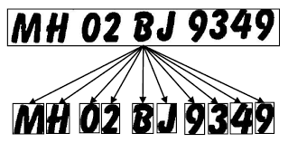

**Figure 2.2:** Image segmentation

**2.3 Experimental results**

This section presents the simulation results of the developed ANPR system. Different images of cars having different colours and structure types are taken and stored in PC. The screenshot of the simulation and are displays below. Two original images of vehicle are shown.

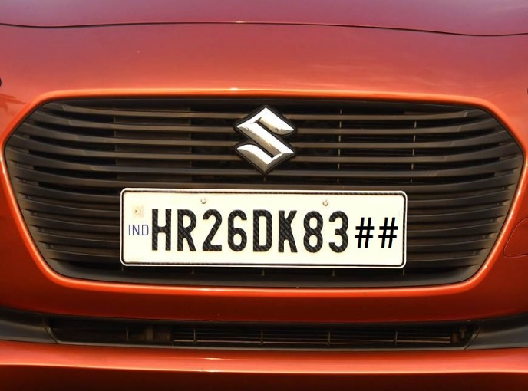



**Figure 2.3 (a):** car images

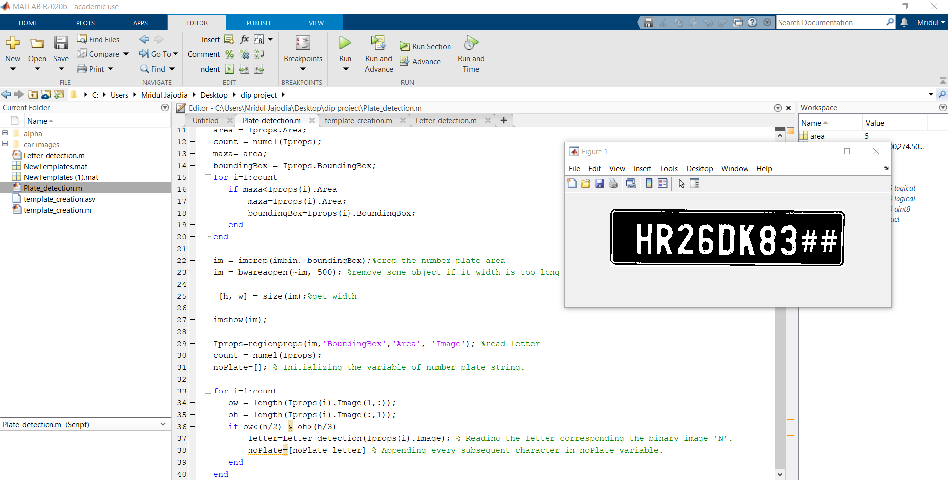

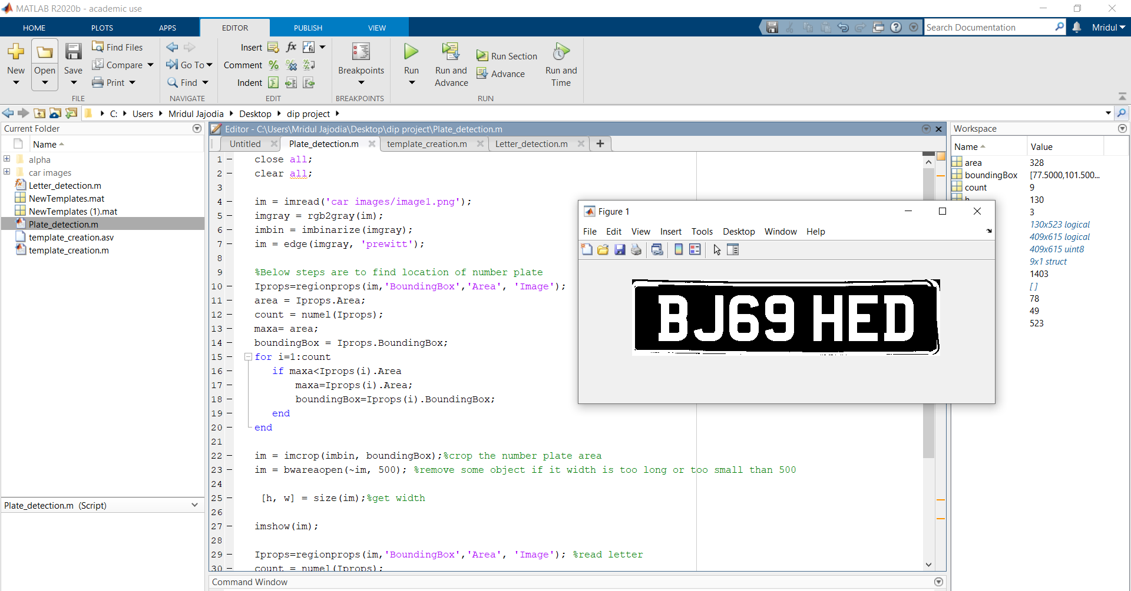

**Figure 2.3 (b):** MATLAB experimental screenshots

**Chapter - 3**

**CONCLUSION**

We have implemented number plate recognition. Our algorithm successfully detects the number plate region from the image which consists of vehicle number & then character segmentation, recognition.We have applied our algorithm on many images and found that it successfully recognition. The project was designed keeping in mind the automation of the number plate detection system for security reason that could replace the current system of manual entry. This project was a success in recording the number plate of a vehicle although it has got its own limitation of image processing.

**REFERENCES**

[1]. Amr Badr, Mohamed M. Abdelwahab, Ahmed M. Thabet , Automatic Number Plate Recognition, Mathematics and Computer Science Series, Vol 38(I),2011, 62-71

[2]. DhirajY. Gaikwad, Promod B. Borole, A Review Paper on Automatic Number Plate recognition ( ANPR) Sytem, International journal of Innovative Research in Advanced Engineering , Vol I Issue,2014

[3]. Rafael C. Gonzalez, Richard E. Woods and Steven L. Eddins, Digital Image Processing using MATLAB

[4]. Ms. Shilpi Chauhan and Vishal Srivastava , “Matlab Based Vehicle Number Plate Recognition”, Page 3-5 , 2017

[5]. Satadal Saha1, Subhadip Basu, Mita Nasipuri, Dipak Kumar Basu,” License Plate Localization from Vehicle Images:An Edge Based Multistage Approach”, International Journal of Recent Trends in Engineering, Vol 1, No. 1, May 2009.